TESOL ICIS, meet the HubICL
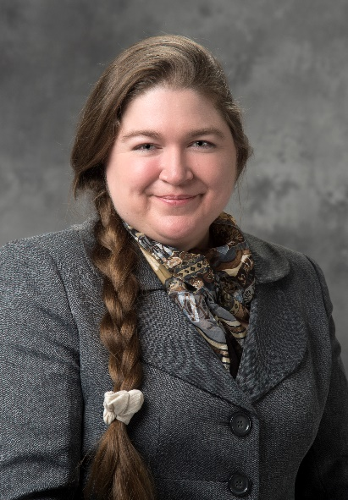
By Dr. Kris Acheson-Clair, Director, CILMAR, Purdue University, USA

In this article, I introduce you to the Intercultural Learning Hub, a science gateway for interculturalists to network, find and share resources, and publish scholarship. After learning the HubICL’s backstory and hearing about its plans for the future, I hope that you will find it useful (and fun) to collaborate!

Dr. Kris Acheson-Clair, former faculty in Applied Linguistics at Georgia State University and Fulbright scholar to Honduras, currently directs Purdue University’s Center for Intercultural Learning, Mentorship, Assessment and Research.

Introductions
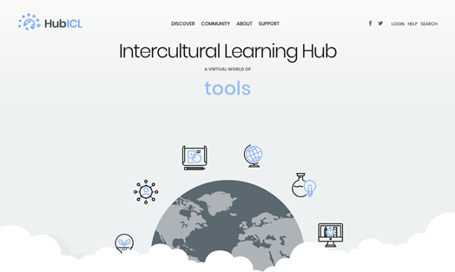
HubICL, I’d like to introduce you to some of the best folks around, the members of TESOL’s Intercultural Interest Section.

TESOL ICIS, meet the HubICL – well, officially the Intercultural Learning Hub, but people only ever say that once before looking for a way to shorten it. Since the url is hubicl.org, most end up at “the HubICL,” pronounced /hʌ:bɪkl/, or even just the Hub. I think you will get along famously, so I’ll get out of the way and let the HubICL tell you their story…

Where It All Started
I am built on the shoulders of giants, theoretical pioneers such as Janet Bennett who gave us the gift of stage-based pedagogy – tailoring curriculum to learners’ stages of intercultural development – as well as early internet innovators like TESOL’s beloved Dave Sperling of the ESL Café who have been building collaborative spaces to share resources online since the internet first became a thing.

I began as a dream to create a one-stop shop for interculturalists. I grew out of a spreadsheet that mapped experiential intercultural activities to learning outcomes and developmental stages. I found a home in the “science gateway” model because it was important to my family that I be robustly grounded in scholarship but profoundly useful to practitioners. I am and will always be accessible at no charge, although I do require a free membership to keep out spammers and hackers.

I was initially developed by the team of intercultural learning specialists at Purdue University’s Center for Intercultural Learning, Mentorship, Assessment and Research, and this team still supports my maintenance and growth. But, like all science gateways, I will only survive with an active membership that continuously contributes new content. I am like language in that way: “Use it or lose it!”

A Guided Tour
Can I show you around? Different folks appreciate various nooks and crannies…

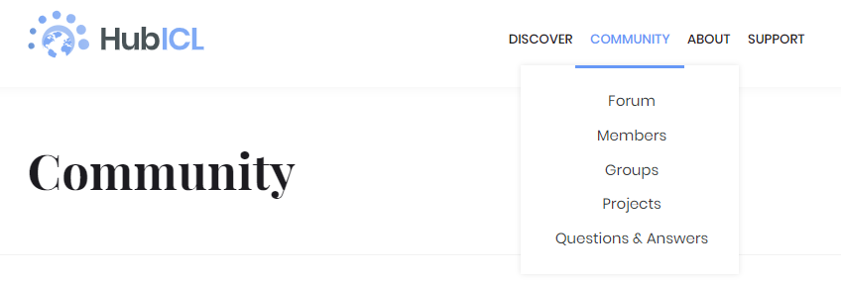
One of my hobbies is helping friends network and collaborate. For example, if you want to work with others on a project, feel free to form a group, open a discussion forum, share project files and more in the Community area.

Or, maybe you’ve done scholarly work that needs to escape the ivory tower and see the light of day. Papers, presentations, posters, videos – innovations of all kinds are welcome in the HubICL Research Repository (under Discover).

Next on the tour is Collections (also under Discover). No debts here; only a space that may seem familiar if you have been on Pinterest. Have favorites you don’t want to lose? Link to or upload them into a themed collection. Keep your favorites private or share them with the world. You can even collect other people’s collections if you like their taste better than your own.

But the spot I think may become the TESOL ICIS hangout is the Digital Toolbox. Those of you who are classroom teachers will want it on speed dial, for sure. Here you’ll find over 600 experiential activities, assessment instruments, media and texts, debriefing and reflection tools, and courses/training programs that support intercultural learning. But wait, it gets better! They aren’t just listed; they are indexed and curated. You can search them by AAC&U VALUE rubric learning outcomes, by orientation on the Intercultural Development Continuum, and by contextual constraints such as how long they take, whether they require movement, and whether or not they cost money. Many have links or downloads for open access (cost-free) materials such as handouts or lesson plans. No, really, don’t applaud. You are embarrassing me.
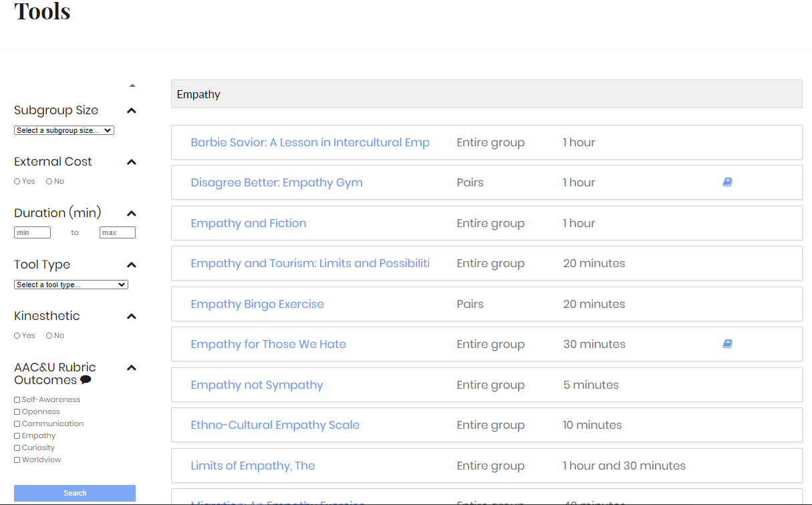

A Gift for New Friends
I’d like to give you a little something to seal our new friendship: Just a taste of what the Digital Toolbox has to offer. If you couldn’t wait and have already registered for a HubICL account, you can follow along as I unwrap this gift for you.

If you were to click on the Discover top menu and choose Tags, you could search for a term such as Icebreaker. Forty-three tools come up in that search. We think of these tools as “icebreakers that teach” – that is, activities that serve the dual purposes of simultaneously supporting intercultural learning and encouraging your students to get to know /grow more comfortable with each other. A couple I would especially recommend for the domestic TESOL setting, where you may have a room full of culturally and linguistically diverse learners, are the Name Game and Voices from the Past. Both of these activities capitalize on the diversity in the room to showcase the cultural values underlying naming practices and traditions in the first case and common sayings in the second. They both are easy enough for novice language learners but still interesting for those at an advanced level. They usually don’t take more than 20-30 minutes (depending on group size), and the materials for them don’t cost money.

For those of you abroad in TEFL settings with classrooms that are more homogenous, I’ve got something for you, too. From the main Toolbox page, try searching a) for an Experiential Tool, b) with no external cost c) that is not kinesthetic and d) focuses on empathy. One of the search returns should be A Flower’s Point of View. We’ve had great success with this CILMAR-original tool for achieving the learning outcomes with culturally homogenous groups: 1) exercising imaginative empathy, and 2) identifying both the possibilities and limits of empathy. It is one of my favorites because it combines individual reflective creative play (in writing mode) with peer-learning through dialogue (in speaking mode).
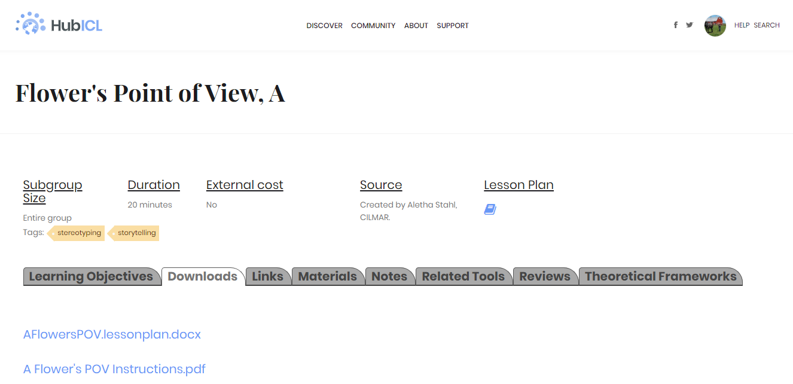

What’s that? Oh, you are very welcome. [shy smile]

What Next?
Hi. Kris here, again.

Thank you for taking the time to read about the HubICL. Looking back over their self-introduction above, I am pleased as punch to see the Hub taking on a life of their own.

Before you go, I’d like to share a bit about what is on the horizon for the HubICL. As we continue to build content in existing areas of the site, behind the scenes a new wing of the Hub is also under construction. You can imagine it as a professional development area. Like the rest of the Hub, the new PD zone is not meant for end-users (learners) but rather for those of us who mentor the development of others (instructors); this space will host train-the-trainer resources such as courses, seminars, certificate programs, graduate degrees, workshops, proprietary assessment trainings, coaching providers, and more. Essentially, it will be a place for interculturalists like you to find and track (with badges for completed modules) professional development opportunities. For PD providers, likewise, it will provide a way to market offerings and at times even deliver content. It should be online in 2021, but meanwhile we welcome any reactions and suggestions that may help us better construct this new addition to the HubICL. You can email cilmar@purdue.edu with your thoughts.

Meanwhile, I hope you enjoyed getting to know the HubICL. I see so much promise in your budding relationship, so I will keep my fingers crossed that you will join the 1900+ existing members in using, building, and spreading the news about your new friend.

Cheers!
Kris

