Three dominant narratives: Our community’s ”stories” about learning across cultural gaps
- Humans learn through exposure to cultural difference
- Humans learn by being immersed in different types of cultural difference
- Humans learn and develop:
  - by being immersed in cultural difference,
  - by reflecting on how they & others frame experience,
  - and by re-framing their experience
First story: students learn when they are exposed to the unfamiliar culture “out there”
- Students learn through exposure to the new and different in privileged places.
- Students learn when educators describe, talk about cultural-specific differences.

The first story is hierarchical: Students encounter sophisticated, “civilized” people & places
- With the Grand Tour—this story’s signature program—learning occurs through exposure to the new & different in privileged places, and through modeling and imitation

With story one, we learn to cross cultural gaps through imitating external models
- To learn, we climb up. . .
- And when we slide down. . .

Second story: Cultural relativism undermines the assumption of cultural hierarchy
- Our common humanity binds us together, and no culture is superior to any other

Second narrative: immersing learners productively through social engineering

The Contact Hypothesis: several “Conditions” need to be present if groups separated by deep differences are to change attitudes about each other:
- Equal status
- Common goals
- Intergroup cooperation
- Authority support
- Friendship potential

Second Story: educators foster learning through “immersing” students in difference
Types of differences educators teach before immersing students:
- Non-verbal communication
- Communication styles
- Learning styles
- Cognitive styles
- Value contrasts

Second story: our community’s core immersion assumptions and practices
- Maximize duration of experience
- Enroll students in host institutions
- Improve second language proficiency
- Maximize contact with host nationals
- Carry out “experiential” activities: Internships, service learning, field work, etc.
- House students with host families or host students

Evidence supporting first and second stories
Most frequently cited: “Study abroad transformed me”

Convergence of disciplinary evidence challenges the positivism of stories 1 & 2: “Constructivism”
- The History of Science (Kuhn)
- Cultural Anthropology (Hall, La Brack)
- Experiential learning theory (Kolb, Osland)
- Developmental theory (Piaget, Perry, Belenky, Kegan, Baxter Magolda)
- Intercultural Communication (Hall, Bennett, Bennett, Hammer)
- Psychology (Lewin, Kelly, Savicki)
- Linguistics (Sapir, Whorf, Deutscher)
- Cognitive Biology (Maturana, Varela)
- Neuroscience (Zull)

Recent research findings also challenge first & second story assumptions about learning
- In the Georgetown Consortium study 1,159 study abroad students enrolled in 61 separate study abroad programs; 138 control students did not study abroad.
- On average, students abroad did not make significant gains in intercultural competence: “a student is all too often in the vicinity of Shanghai without having a Shanghai experience.”
- While learning gains of female students were not large, they did, on average, learn & develop significantly more—interculturally and linguistically—than did males.

Core Georgetown Study findings: To what extent do traditional “immersion” practices foster intercultural learning?
- Send students abroad for longer periods: Limited impact
- Take steps to improve SL proficiency: No impact
- Maximize contact with host nationals: No impact
- Enroll in host school classes: No impact
- Doing Internships, service learning: No impact
- Maximizing contact with host nationals: No impact
- Being housed in home stays: No impact
- Pre departure cultural orientation: Yes—some impact
- Home stays: Yes—when students engaged with host family
- Cultural mentoring at sites abroad: Yes—the highest impact practice in the study

Third Story: how each of us frames an event determines what it means
- We begin to learn interculturally as we become aware of how we and others typically frame our experiences:“ We don’t see things as they are, we see things as we are.” (Anias Nin)

Third story: Since most students abroad don’t develop on their own, educators need to intervene
- Educators help students learn to interact more effectively and appropriately in unfamiliar cultural contexts through:
- Helping immerse students in difference—part of the time
- Helping students learn to reflect—and thus to become aware of the ways that they and others characteristically frame experience
- Helping students learn to re-frame—that is, to shift perspective and adapt behavior to other cultural contexts

An influential third story learning theory: Learning is experiential, developmental and holistic
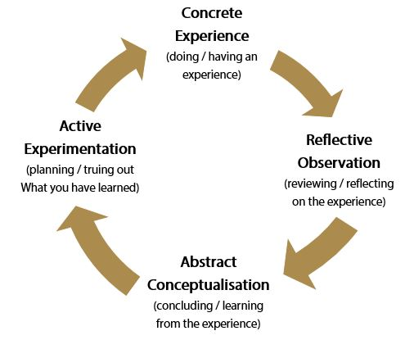

An influential developmental theory: the Intercultural Development Continuum
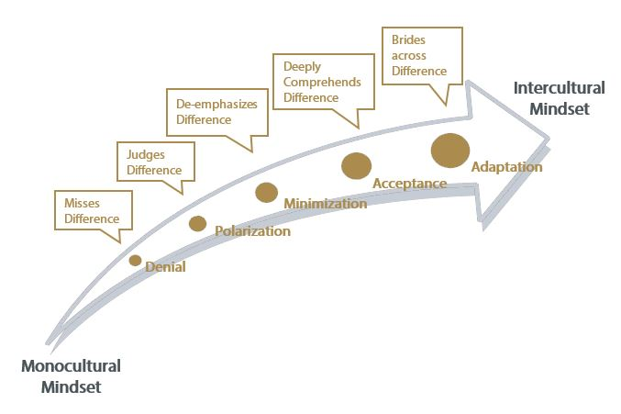

Facilitating intercultural development through study abroad: 4 current approaches to intervention
- Faculty or staff living at sites abroad train students through required or elective courses
- Home campus faculty accompanying students train them at sites abroad
- Faculty and staff train students before and after study abroad through required training courses
- Faculty or TAs at home campuses train students, on line, while students are abroad

Assessing Intercultural Development: Comparative Program Data (IDI=90-point scale)
SA without facilitation at program site: IDI Gains
- Georgetown U. Consortium Study (60 progs.) +1.32

SA with facilitation across program: IDI Gains
- U of Pacific training program +17.46
- AUCP training program (Aix, Marseille) +13.00
- CIEE training program (20 programs, fall 2012) +11.34
Four core intercultural competencies: Helping students learn to interact more effectively and appropriately with culturally different others means:
  - Helping them increase their cultural and personal self-awareness through reflecting on their experiences;
  - Helping them increase their awareness of others within their own cultural and personal contexts;
  - Helping them learn to manage emotions in the face of ambiguity, change, and challenging circumstances & people
  - Helping them learn to bridge cultural gaps—which is to say, helping them learn to shift frames and adapt behavior to other cultural contexts.

mvandeberg@mvbassociates.com

Vande Berg, M., Paige, R. M., & Lou, K. H. (Eds.) (2012). Student learning abroad: what our students are learning, what they’re not, and what we can do about it. Sterling, VA: Stylus.
Allport, G. W. (1954). The Nature of Prejudice. Reading, MA: Addision-Wesley. Pettigrew, T. (1998). Intergroup contact theory. Annual Review of Psychology, 49, 65-85. Pettigrew, T. (2008). Future directions for intergroup contact theory and research. International Journal of Intercultural Relations, 32, 187-199.
Vande Berg, M. (2009). Intervening in student learning abroad: A research-based inquiry. (M. Bennett, Guest Ed.) Intercultural Education, Vol. 20, Issue 4, pp. 15-27.
Vande Berg, M.; Connor-Linton, J.; & Paige, R. M. The Georgetown Consortium Study: Intervening in student learning abroad. Frontiers: the Interdisciplinary Journal of Study Abroad. Vol. XVIII, pp. 1-75.
Kolb, A. & D. Kolb. (2005). Learning styles and learning spaces: Enhancing experiential learning in higher education. Academy of Management Learning & Education, Vol. 4, No. 2, 193-212.
Intercultural Development Inventory (IDI): www.idiinventory.com; Hammer, M. (2012).
Hammer, M. (2012). The Intercultural Development Inventory: A new frontier in assessment and development of intercultural competence. In Vande Berg, M., Paige, R. M. & Lou, K. H. (Eds.). What our students are learning, what they’re not, and what we can do about it. Sterling, VA: Stylus.

