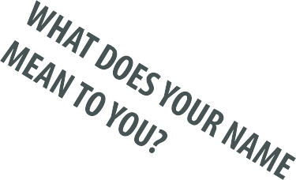
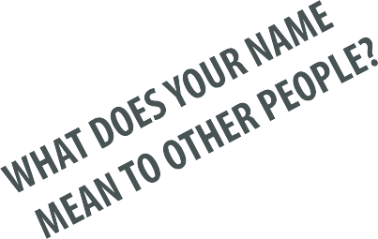

The Story of My Name

The Name Game

Description of a Name Game & Get-to-know-you Activity
What's in a name? More than we often realize. This is an interesting, novel way for people to introduce themselves to others, especially in ethnically diverse groups. Ensure that an appropriate group atmosphere is established in which people have already done some initial warm-up activities and name games.
- Ask participants to turn to a partner and explain what your name means (if anything) and where it comes from.
- Most people reveal a surprising amount of interesting information about where their name comes from and what it means.
- The greater the ethnic and cultural diversity in the group, the better this exercise tends to work.
- Can be specifically used to help build intercultural respect and understanding or to more generally help develop self-identity and open respect and sharing.

Optional: Ask each person to introduce his/her partner to the larger group and to explain what his/her name means and where it comes from.
Optional: The activity can be extended into revealing the background behind other names e.g.,
- Nicknames
- Pets
- Alter-ego or "fantasy name"
- Names of children - or what would you name your children if you have them?

Equipment: None
Time: ~30 mins
Brief description:
Where does your name come from? Share the story of where your name comes from and what your name means. Everyone's name has a surprisingly interesting origin. Helps to build intercultural respect and understanding.

