Navigating the new IDI (Enterprise) account Website:

A step-by-step guide

The Center for Intercultural Learning, Mentorship, Assessment and Research (CILMAR)

Purdue University
cilmar@purdue.edu

QA Website: https://www.idiassessment.com/
Assessment Participant site: https://idi5.idiassessment.com/

Dr. Daniel Jones, Intercultural Learning Specialist
Katherine Yngve, Associate Director of Intercultural Outcomes Assessment
Retrieve logins – https://www.idiassessment.com/Account/Login

New Dashboard
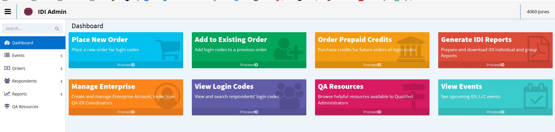

Switching Accounts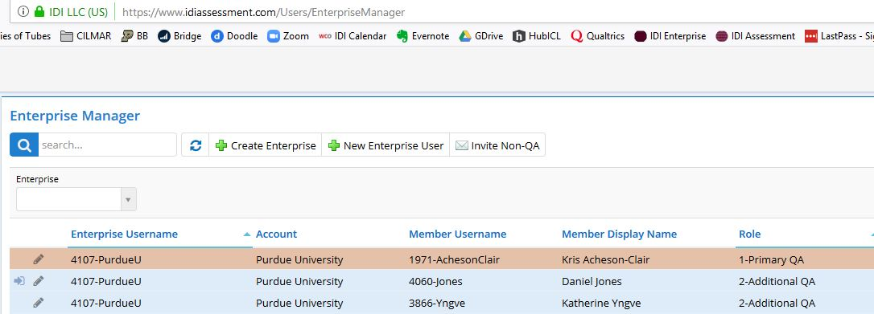

Placing New Orders

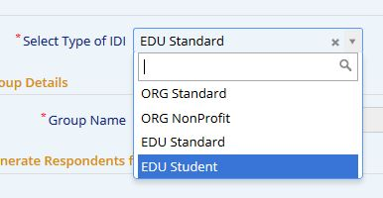
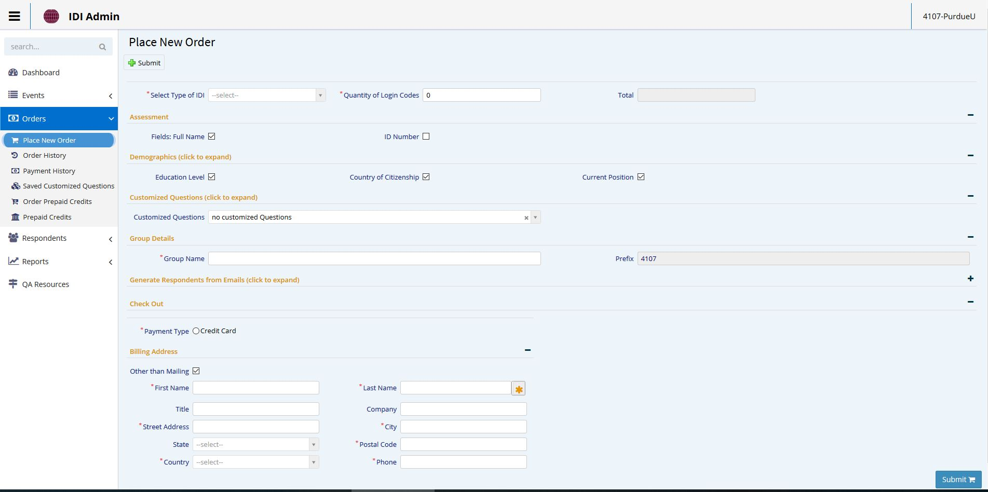

Pricing
Faculty/Staff (EDU Standard) = $18.00 (⬆$3.00)
Student (EDU Student) = $12.00 (⬆$1.00)

Add to Existing Orders

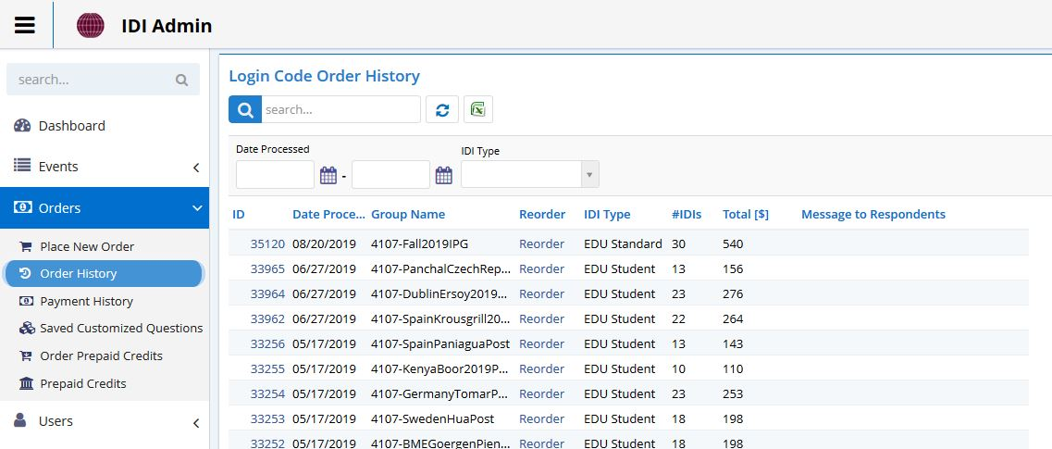

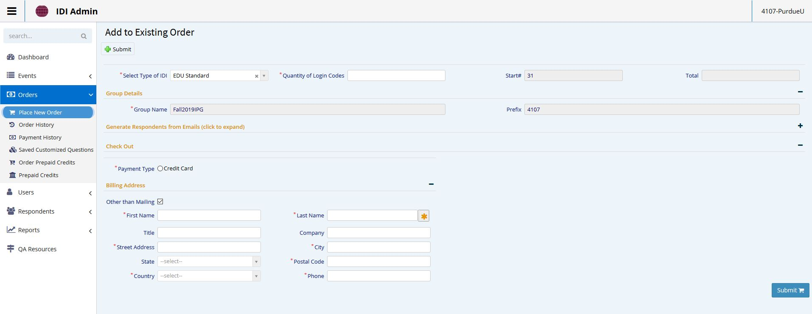

Change Username & Passwords
No longer an option

Convert to Credits

View login Codes

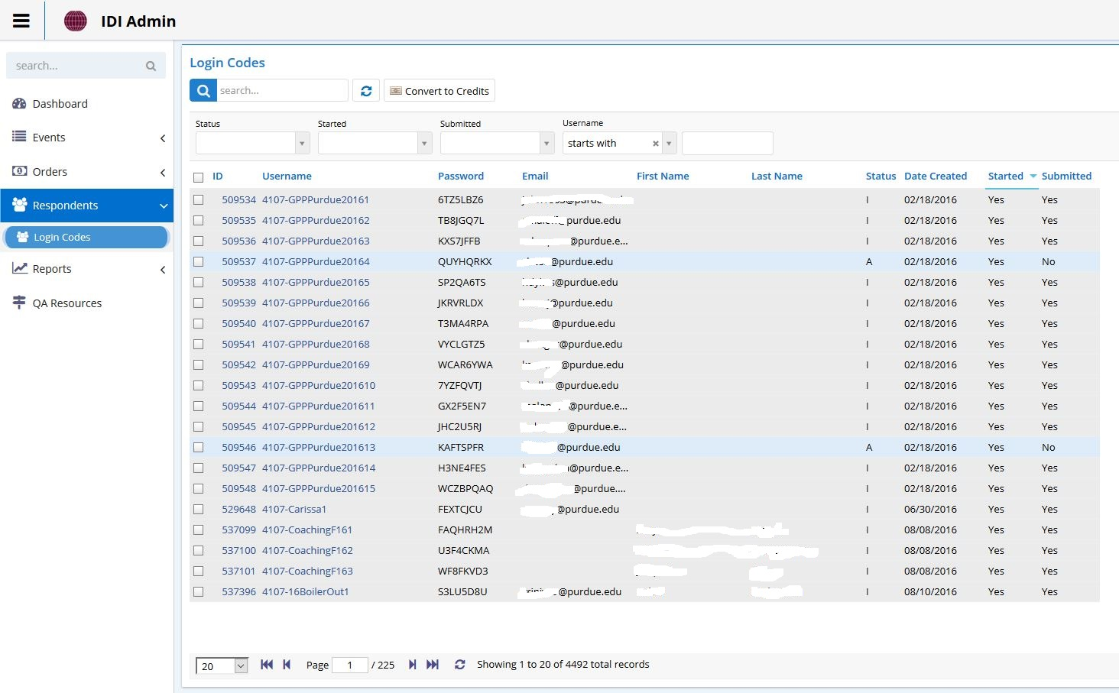

Generate Reports

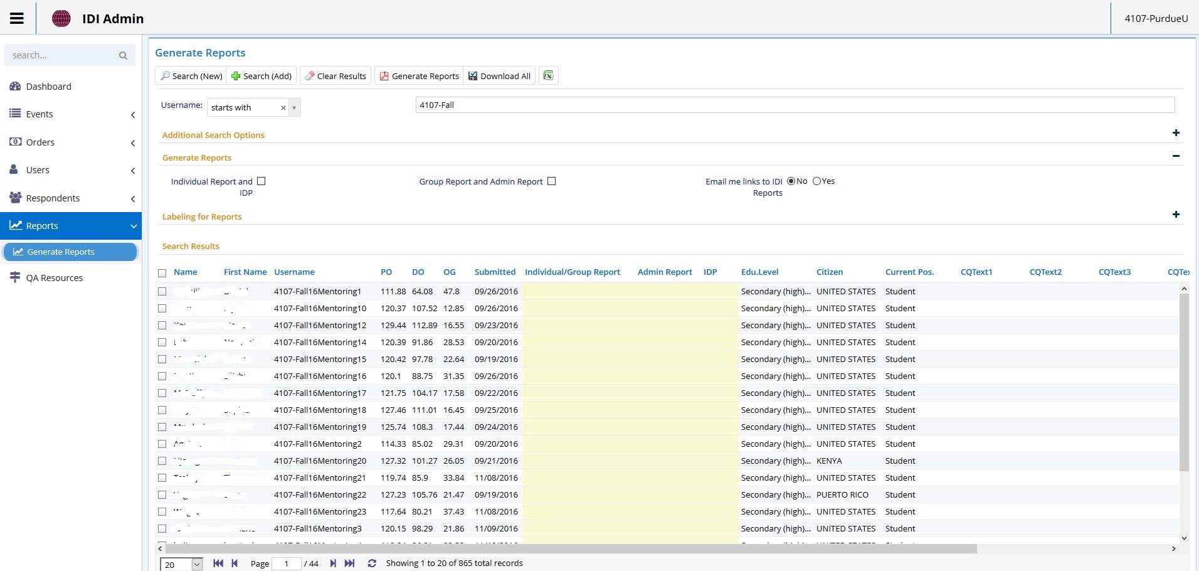

Export Data

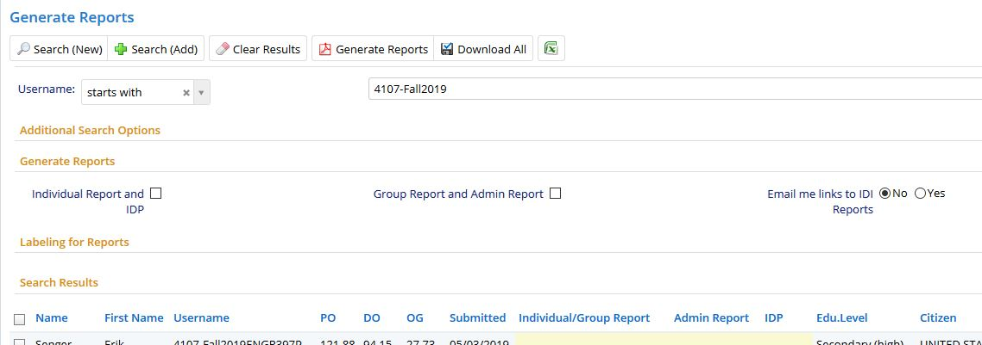

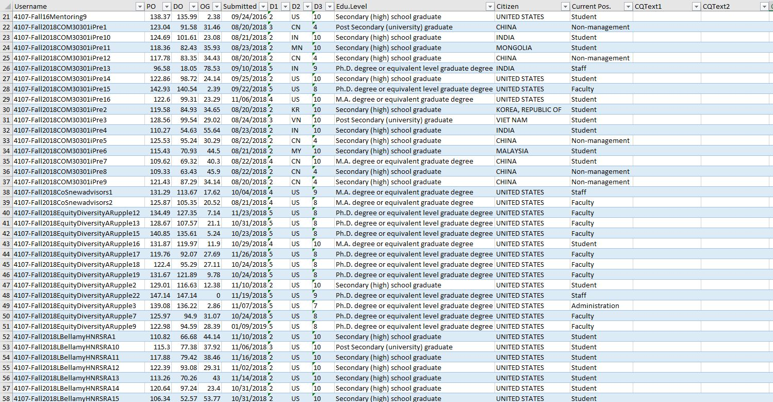

Data on individual responses to each question are no longer available.

QA Resources
