Global Science Partnerships Learning Community: The First Six Years

Laura Starr
Director for Experiential Learning and Student Success
College of Science, Purdue University
lstarr@purdue.edu

Katherine Yngve
Associate Director of Learning Outcomes, CILMAR
Intercultural Learning Specialist, IDA+A
Purdue University
kyngve@purdue.edu

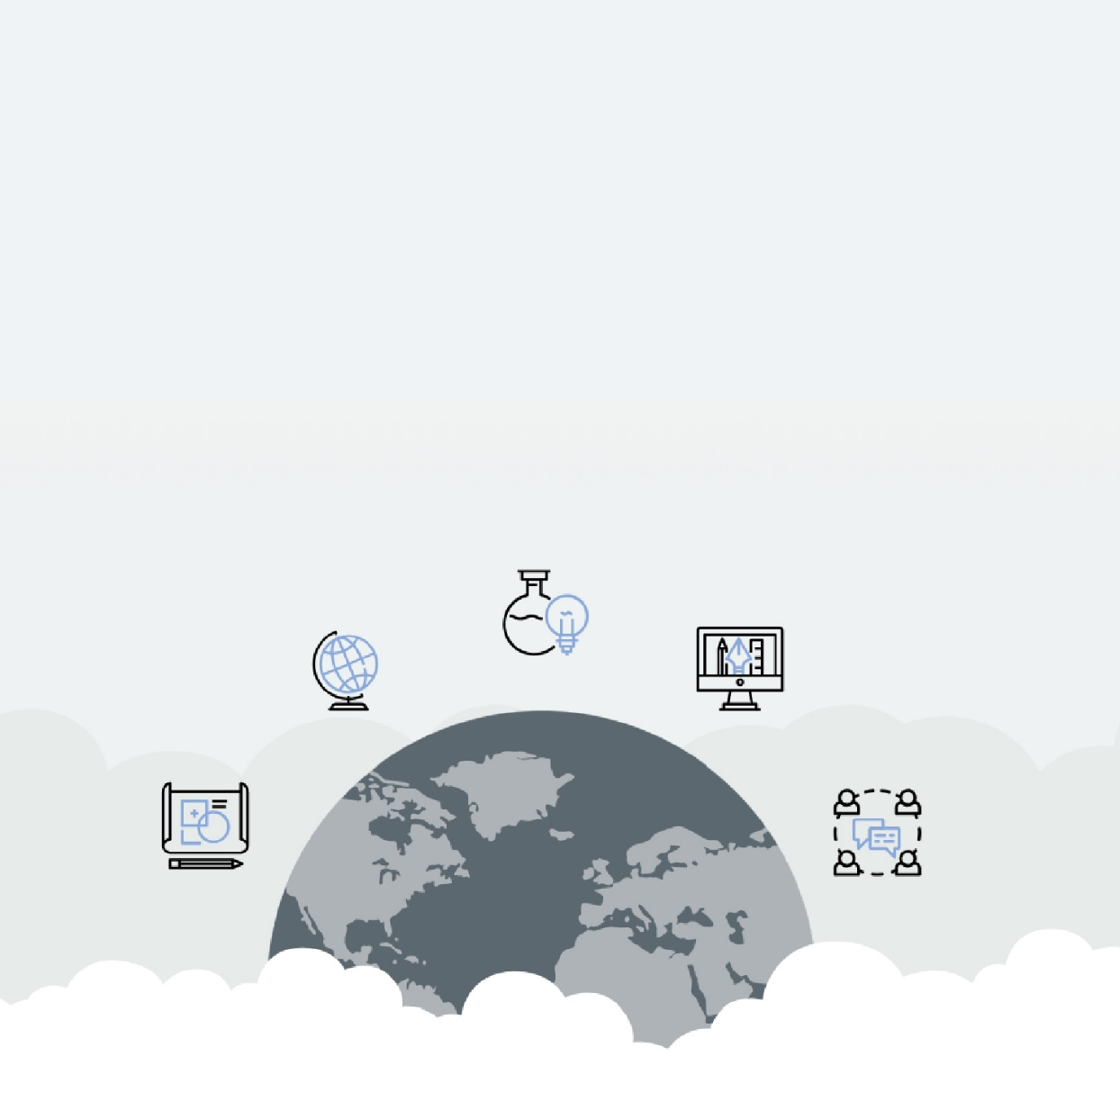

December 2019
HubICL
Table of Contents
LIST OF TABLES 3
LIST OF FIGURES 4
ABSTRACT 5
INTRODUCTION 6
SECTION 1 BRIEF LITERATURE REVIEW 7
SECTION 2 RESEARCH DESIGN AND METHOD 8
SECTION 3 QUANTITATIVE FINDINGS AND DISCUSSION 9
SECTION 4 RUBRIC-BASED ANALYSIS AND RESULTS 11
SECTION 5 FUTURE DIRECTION 14
SECTION 6 CONCLUSIONS 14
REFERENCES 15

LIST OF TABLES

Table 1. Initial Mean Developmental Orientation (DO) Scores 9
Table 2. AAC&U Milestone Level 3 12

LIST OF FIGURES

Figure 1. Demographics of GSP LC Cohorts 7
Figure 2. Intercultural Development Inventory (IDI) 8
Figure 3. Change of Developmental Stage 10
Figure 4. Percent of Cohort at AAC&U Rubric Level 3 or Above 13

ABSTRACT

Living-learning communities seem to offer rich settings for the development of cultural competencies; yet seldom do they measure intercultural learning outcomes. Drawing on Bennett's developmental model of intercultural sensitivity and Sanford's theory of challenge and support, this study uses mixed assessment methods to analyze learning outcomes for six cohorts of students in a first-year "global science" learning community for international and domestic students. Data suggest that focusing excessively on dealing with difference may be counter-productive; while attention to developing self-awareness and empathy can significantly increase the competence outcomes for members of both groups.

INTRODUCTION

In 2010, the percentage of international undergraduates in the College of Science was just under 18%. The following year, 2011, and in subsequent years that proportion was well over 25%. Not only were there many more international students in the College, but we noticed that there was little interaction between international and domestic students, impeding academic teamwork and residence hall life. The international students, mostly Chinese, studied and hung out with students like themselves, as did the domestic students. We saw this as a challenge and an opportunity to increase the intercultural competence of both these populations so that they could ultimately learn from and about each other, and work together.
The Global Science Partnerships Learning Community - a learning community for first-year College of Science students, consisting of a living community, a leadership seminar, and an array of co-curricular and social activities, was founded in 2013. Students live together in a residence hall. The leadership seminar introduces students to the concepts of culture, cultural differences, intercultural conflict, and intercultural leadership. Students hear from faculty as to the collaborative and cross-cultural nature of science. They complete classroom exercises and homework assignments that encourage them to pay attention to culture and reflect on its meaning. For co-curricular and social activities, these first-year learning community students are partnered with upperclassmen—usually in the same major. Initially, these partnerships aid in the transition to college, and eventually informal mentoring relationships develop. Together, students take part in activities that aim at increasing their cross-cultural effectiveness. They also participate in service events, bringing domestic and international students together in striving to reach an authentic, non-academic common goal. For instance, together they put on an annual trunk-or-treat event at the local YMCA.
The first year of the learning community (LC) was 2013. Over the years the LC has ranged in size from a high of 34 in 2018 to a low of 12 students in 2016. The proportion of international students has varied between one-half and one-third. The majority of international students hail from either China or India. Usually the ratio of males to females is about 2/1.
Figure 1. Demographics of GSP LC Cohorts

SECTION 1 BRIEF LITERATURE REVIEW

Intergroup Contact Theory (Allport, 1954; Sherif & Sherif, 1969) informs us that it is not enough to bring two groups together in order to promote learning, positive attitudes and the willingness to work together. The required conditions are for the groups to have equal status, common goals, cooperative structure, the support of authorities, laws or customs, and informal personal interaction. To this, Sanford (1962) adds that in educational contexts, learning and attitudinal changes fail to occur when contact situations create boredom, anxiety or aversion for the participants. The Developmental Model of Intercultural Sensitivity or DMIS (Bennett, 1986) identifies how an individual advances beyond ethnocentrism and becomes effective and appropriate across difference.

SECTION 2 RESEARCH DESIGN AND METHOD

Based on intergroup contact theory and using challenge and support, the Learning Community has been structured in such a way so as to promote students’ intercultural competency development along the intercultural continuum. Reflective assignments, in-class exercises, and co-curricular activities are employed in pursuit of this outcome. The Intercultural Development Inventory (IDI) is used to assess the extent to which this outcome is achieved. The IDI is a cross-culturally validated survey instrument comprised of a 50-item questionnaire, which has been found to have little to no social desirability bias. The instrument identifies a test-taker’s developmental stage along a 5-stage continuum ranging from mono-cultural (ethnocentric) to intercultural (ethno-relative). Among other things, it measures a student’s Developmental Orientation (DO), which captures the mindset from which that individual functionally operates in situations where cultural differences need bridging.

Figure 2. Intercultural Development Inventory (IDI)
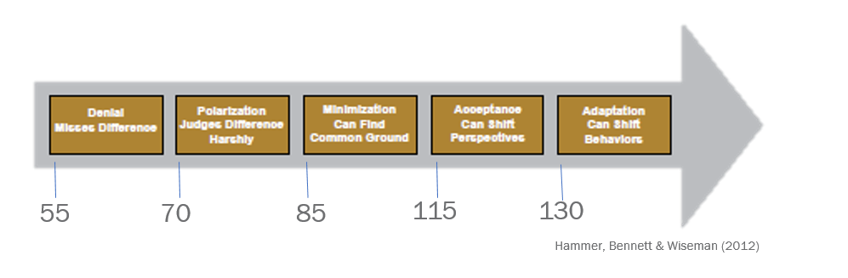

SECTION 3 QUANTITATIVE FINDINGS AND DISCUSSION

The initial mean DO scores for our first 6 cohorts are within 3 points of each other: at the cusp of minimization, meaning that on average our students are ready to seek common ground with each other and others, despite their differences. No difference was found between the initial DO scores of international and domestic students, nor between males and females. Students retook the IDI at the end of their first semester.
Table 1. Initial Mean Developmental Orientation (DO) Scores
Entering year | 2013 | 2014 | 2015 | 2016 | 2017 | 2018
# of students | 30 | 27 | 14 | 12 | 23 | 30
Initial mean DO | 84 | 87 | 86 | 87 | 85 | 84

During the first 2 years of the learning community 20-30% of the participants regressed a stage or two on the IDI from the beginning to the end of the semester. The trends are inconsistent for the two small 2015 and 2016 cohorts: whereas 2015 saw very few students regress and a majority advance a stage or two, the 2016 cohort saw approximately equal numbers regress and advance a stage. In 2017 and 2018, approximately 40% of the participants advanced a stage or two. Please note that if a student began the learning community in minimization, it would take twice the gain for him or her to make it to the next stage (see the figure above for the score range between stages).

Figure 3. Change of Developmental Stage

2013-14: In the first few years we took what students had in common for granted, and the discussions and assignments emphasized the differences between them. Students explored ways of categorizing and responding productively to difference. The instructors assumed that since cultural differences were likely to cause conflict, students should be taught to deal with them. The result was that by concentrating on differences, rather than balancing commonalities with differences, some students were pushed out of their comfort zones, as reflected both in ad hoc comments to the instructors and eventual regression in their IDI developmental orientation scores.
2015-16: During these middle years, there was a better balance of challenge and support, including more exercises that are known to help people in minimization advance along the continuum (increase cultural self-awareness, help with finding common ground, develop the ability to perceive others accurately and non-judgmentally, and distinguish between stereotypes and cultural generalizations). This balanced portfolio of assignments seemed to have worked better for the 2015 than for the 2016 cohort. The only explanation we have is that the very small 2016 cohort never seemed to coalesce.
2017-18: Up until 2017, we were using the IDI for assessment and programming purposes only. In 2017 we added 2 new elements to the program: 1. IDI debriefing. Each student was debriefed regarding their own profile on the intercultural development continuum. This consisted of an hour-long meeting with an IDI Qualified Administrator (QA) during which the student and QA together explored how the individual student engages difference in their day-to-day interactions with others. These conversations were directed toward growth and development; 2. Embedded intercultural activities. Activities and self-reflections from the Intercultural Development Plan (IDP) that build intercultural competence were incorporated into the course assignments.

SECTION 4 RUBRIC-BASED ANALYSIS AND RESULTS

In order to investigate the increased proportion of students advancing a stage or two in the later years, we analyzed two assignments that were introduced in 2014. Students complete these assignments about three-quarters of the way through the semester. The assignments ask students to discuss the intercultural challenges they had successfully overcome and those they had failed to overcome since coming to Purdue.
Using content analysis and the AAC&U Intercultural Knowledge & Competence Value Rubric, we asked what percentage of the cohort reached mastery level 3.Since we did not specifically ask students to address all the elements of the AAC&U rubric, there were two categories, Knowledge of Worldview Frameworks and Curiosity, with insufficient evidence for analysis. So, we will report on the results for the other four categories.
Table 2. AAC&U Milestone Level 3
Knowledge:  Cultural Self-Awareness | Recognizes new perspectives about own cultural rules and biases (e.g. not looking for sameness; comfortable with the complexities that new perspectives offer).
Skills:  Empathy | Recognizes intellectual and emotional dimensions of more than one worldview and sometimes uses more than one worldview in interactions.
Skills:  Verbal & nonverbal communication | Recognizes and participates in cultural differences in verbal and nonverbal communication and begins to negotiate a shared understanding based on those differences.
Attitudes:  Openness | Begins to initiate and develop interactions with culturally different others. Begins to suspend judgment in valuing her/his interactions with culturally different others.

Assignments from 2014, 2015, 2017, and 2018 were analyzed (see the chart below). 2014 seems to be the outlier when we look at self-awareness, empathy, and communication. Far fewer students reached level 3 in 2014 than they did in 2015, 2017, and 2018. The results regarding openness highlight a different trend: 45-50% of the 2017 and 2018 cohorts demonstrated openness at level 3 (while the percentage for the 2014 cohort is 28% and for the 2015 cohort is 33%). This means that almost half of the students in the 2017 and 2018 cohorts have begun to initiate and develop interactions, and suspend judgment in valuing her/his interactions with culturally different others. It makes sense that the introduction in 2017 of the individual debrief and the vulnerability that it entails, accounts for this result.
Figure 4. Percent of Cohort at AAC&U Rubric Level 3 or Above

SECTION 5 FUTURE DIRECTION

As a result of these findings, we will continue tweaking the learning community framework. We will take into account the following situations and activities that students find particularly challenging:
• Residing together with students from different cultures,
• Finding ways to accommodate differences in their everyday lives, and
• Activities that require students to explore their differences with other participants openly and directly;
And those that help students learn ways to bridge difference:
• Reflection on their own cultural backgrounds and behaviors in intercultural situations,
• Exploration of what they have in common with other students, and
• Working together in equal roles to achieve a common goal.

SECTION 6 CONCLUSIONS

So far, what we have managed to demonstrate is that a semester-long learning community for first-year students of mixed cultural backgrounds, when it uses the high-impact intercultural mentoring methods of cutting-edge study abroad programs, can foster significant intercultural competence growth for domestic and international students alike. Not only does participation in such a learning community foster the skills needed for a successful career, but by investing in these skills early in students’ academic careers, such a program can further students’ integration into and sense of belonging to the full university community — an inclusive win-win situation for all involved.

REFERENCES

Allport, G. W. (1954). The nature of prejudice. Oxford, England: Addison-Wesley.
Bennett, M. (1986) A developmental approach to training for intercultural sensitivity. International Journal of Intercultural Relations, 10 (2), 179-186.
Sanford, N. (1962). The American college: A psychological and social interpretation of the higher learning. New York: Wiley.
Sherif, M. & Sherif, C.W. (1969). Social psychology. New York: Harper & Row.

